MYSQL Database Assignments

Week 2 Assignments

**Assignment 6: Subqueries**

1. Find students who scored above the **average score** using a subquery.

SELECT

*

FROM

students

INNER JOIN

marks

ON students.student_id=marks.student_id

WHERE

marks.score >

(SELECT AVG(score) FROM marks);

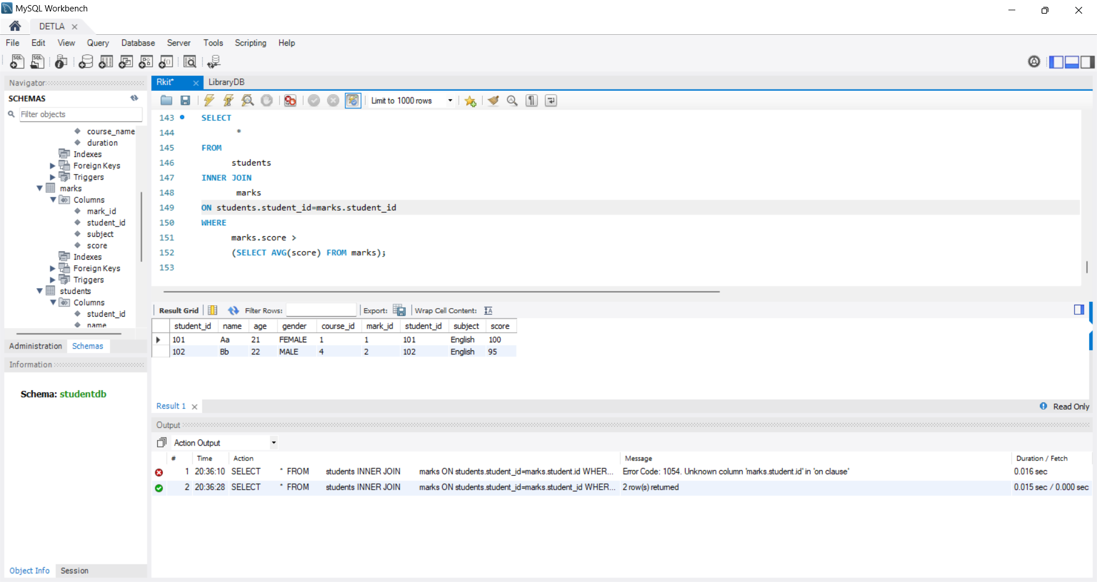

1. Get students enrolled in the same course as “John” using a **correlated subquery**.

select * from students WHERE course_id=(SELECT course_id FROM students WHERE name ='John') AND name !='John';

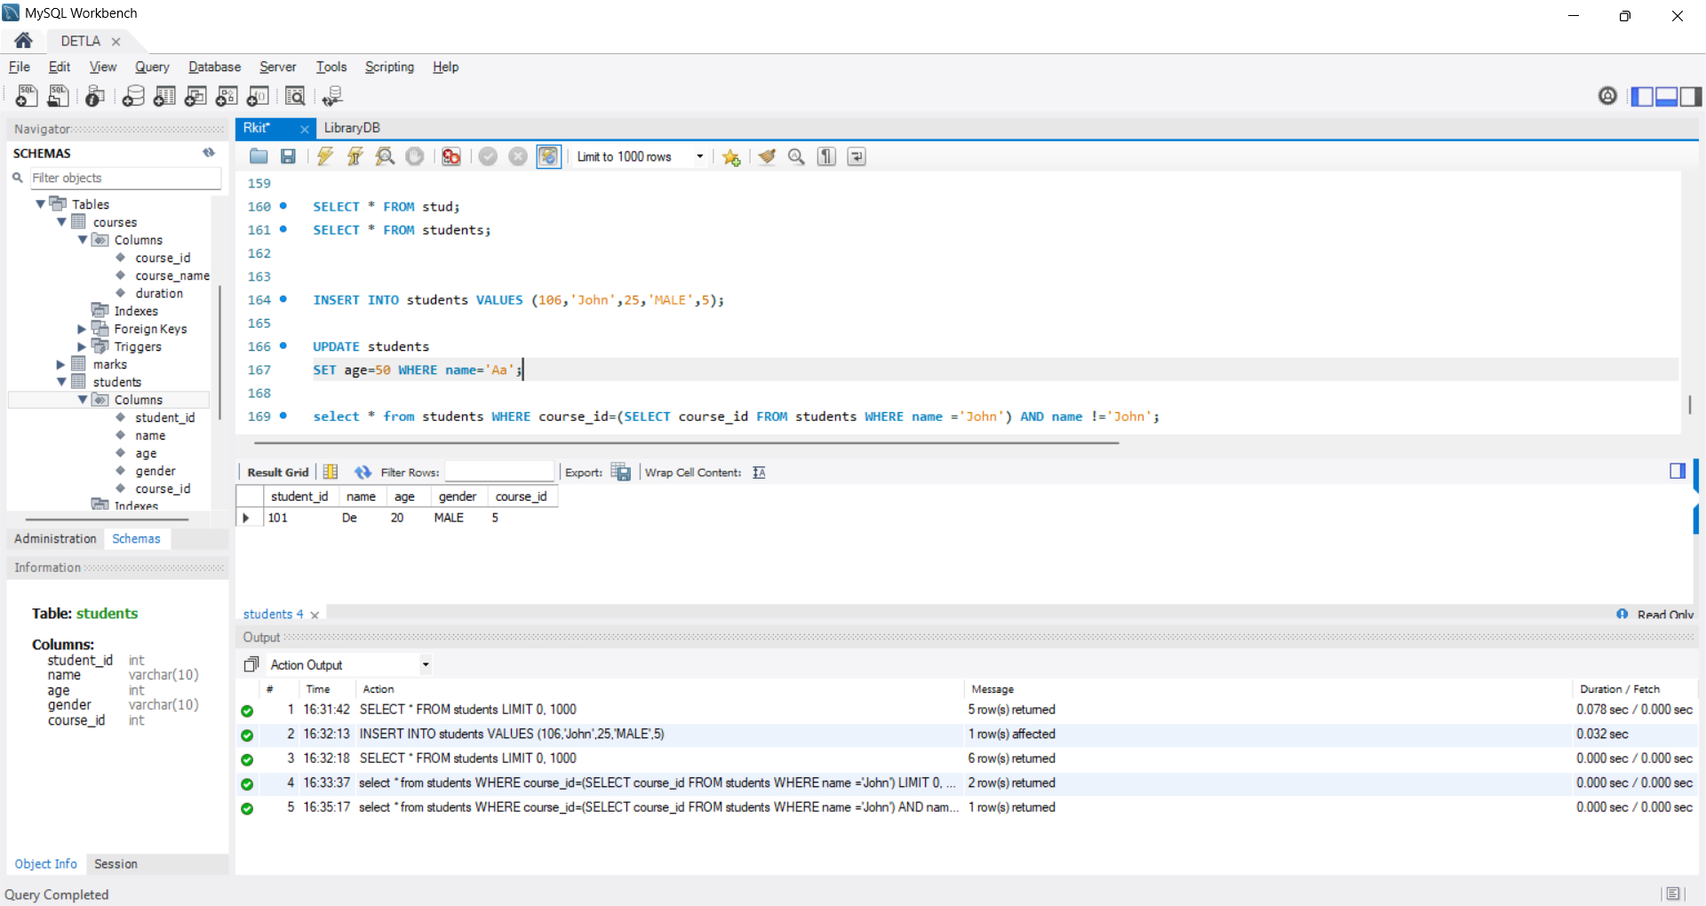

**Assignment 7: UNION & Set Ops**

1. Write a query to list all distinct course names from Courses and Marks tables (use UNION).

SELECT Distinct(course_name) AS course FROM courses

UNION

SELECT DISTINCT(subject) AS course FROM marks ;

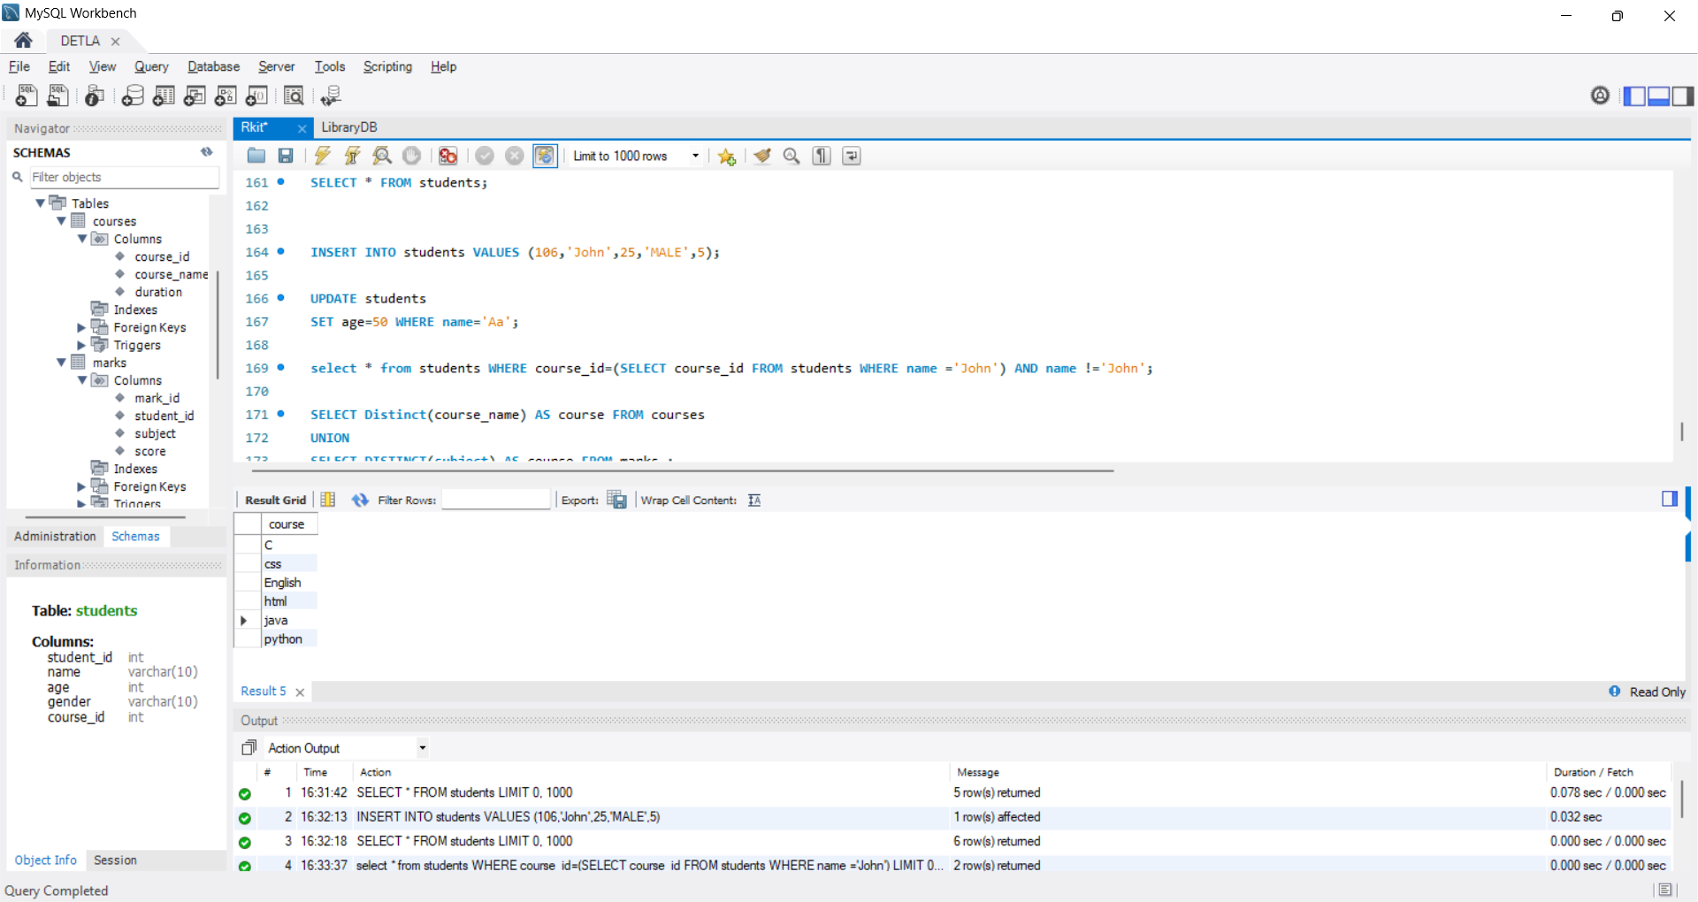

1. Write another query to include duplicates (use UNION ALL).

SELECT Distinct(course_name) AS course FROM courses

UNION ALL

SELECT DISTINCT(subject) AS course FROM marks ;



**Assignment 8: Constraints & Performance**

1. Add a **PRIMARY KEY** on student_id.

ALTER TABLE students

ADD PRIMARY KEY (student_id);

1. Add an **AUTO_INCREMENT** to course_id.

ALTER TABLE courses MODIFY course_id INT NOT NULL AUTO_INCREMENT PRIMARY KEY;

1. Create an **INDEX** on email for faster search.

CREATE INDEX idx_student_name ON students(name);

1. Prove query optimization difference using EXPLAIN with and without index.

EXPLAIN select * from students where name='John';

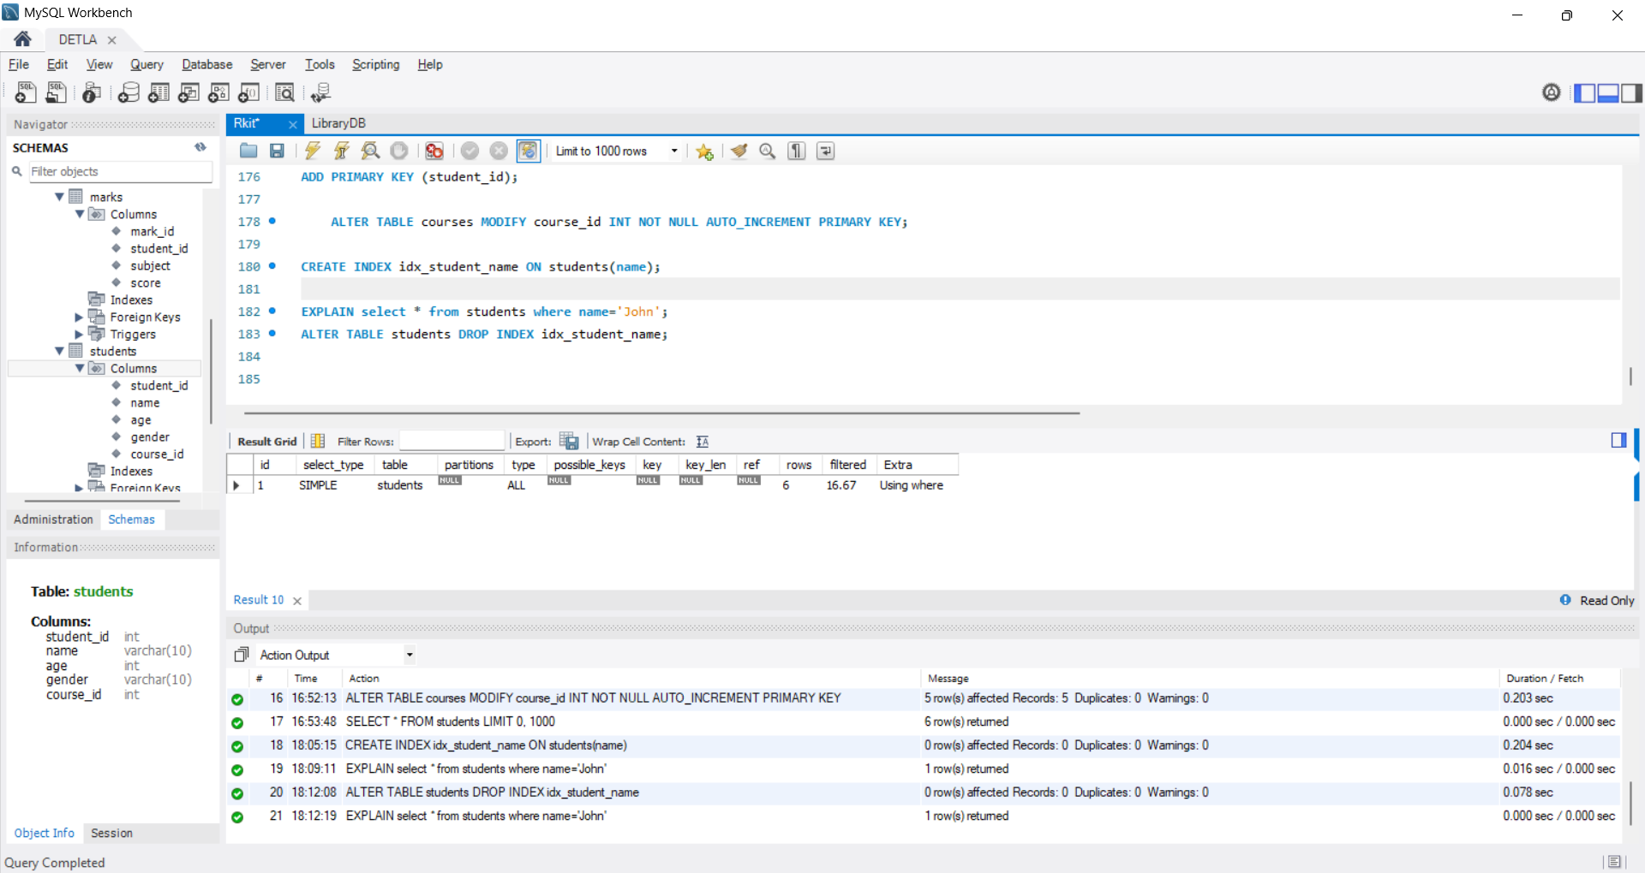

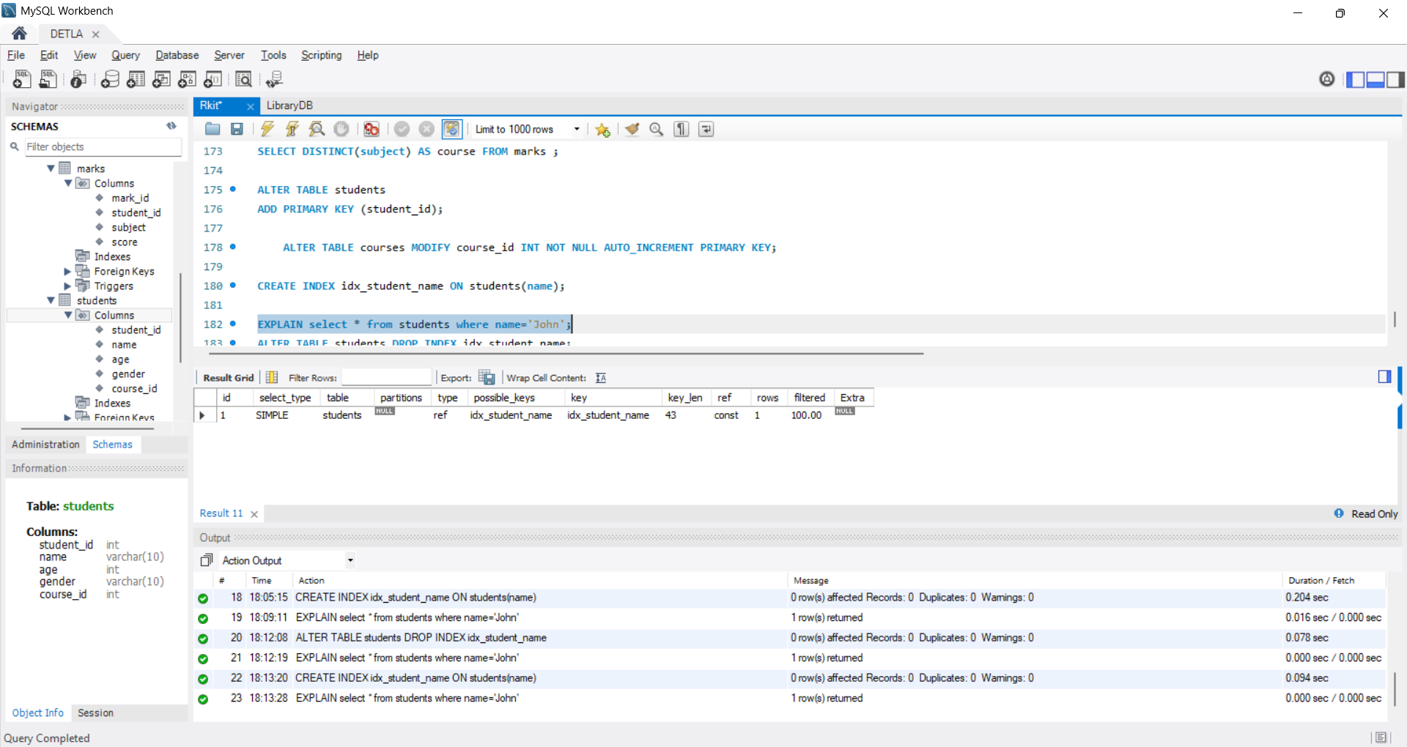

**Assignment 9: Stored Programs**

1. Write a **Stored Procedure** to return all students enrolled in a given course.

DELIMITER //

CREATE PROCEDURE stu_enr (IN stu_course_id INT)

BEGIN

SELECT * FROM students

WHERE course_id=stu_course_id;

END //

CALL stu_enr(5);

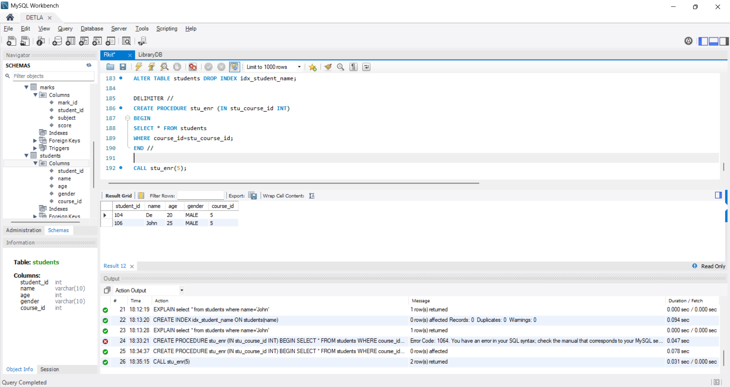

1. Create a **Function** to calculate grade based on marks (e.g., A/B/C).

DELIMITER //

CREATE FUNCTION grade ( marks_stu INT)

RETURNS CHAR(2)

DETERMINISTIC

BEGIN

DECLARE grade CHAR(2);

IF marks_stu > 90 THEN

SET grade='A';

ELSEIF marks_stu >75 THEN

SET grade='B';

ELSEIF marks_stu > 45 THEN

SET grade='B';

ELSE

SET grade='F';

END IF;

RETURN grade;

END //

SELECT grade(94) AS grade ;

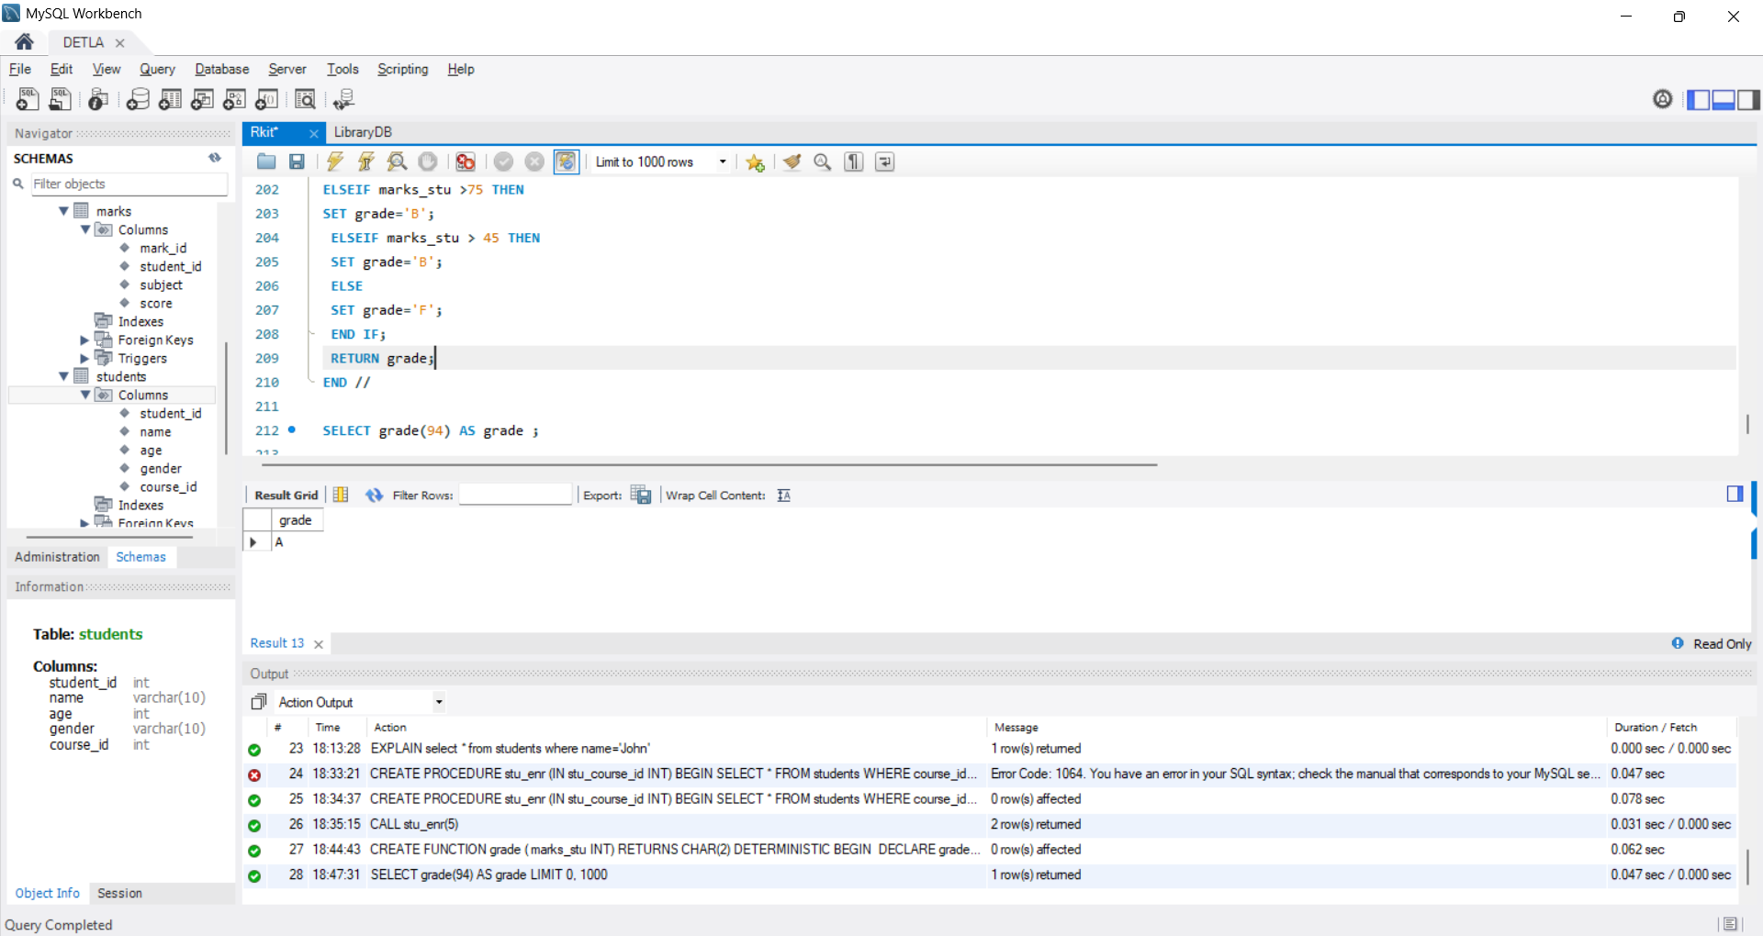

1. Create a **Trigger** to log deleted student records into a new table DeletedStudents.

DELIMITER //

CREATE TRIGGER trg_after_student_delete

AFTER DELETE ON students

FOR EACH ROW

BEGIN

INSERT INTO DeletedStudents (student_id, name, age, gender, course_id)

VALUES (OLD.student_id, OLD.name, OLD.age, OLD.gender, OLD.course_id);

END //

CREATE TABLE DeletedStudents (

deleted_id INT AUTO_INCREMENT PRIMARY KEY,

student_id INT,

name VARCHAR(100),

age INT,

gender VARCHAR(10),

course_id INT,

deleted_at TIMESTAMP DEFAULT CURRENT_TIMESTAMP

);

SELECT * FROM DeletedStudents;

DELETE FROM Students WHERE student_id=105;

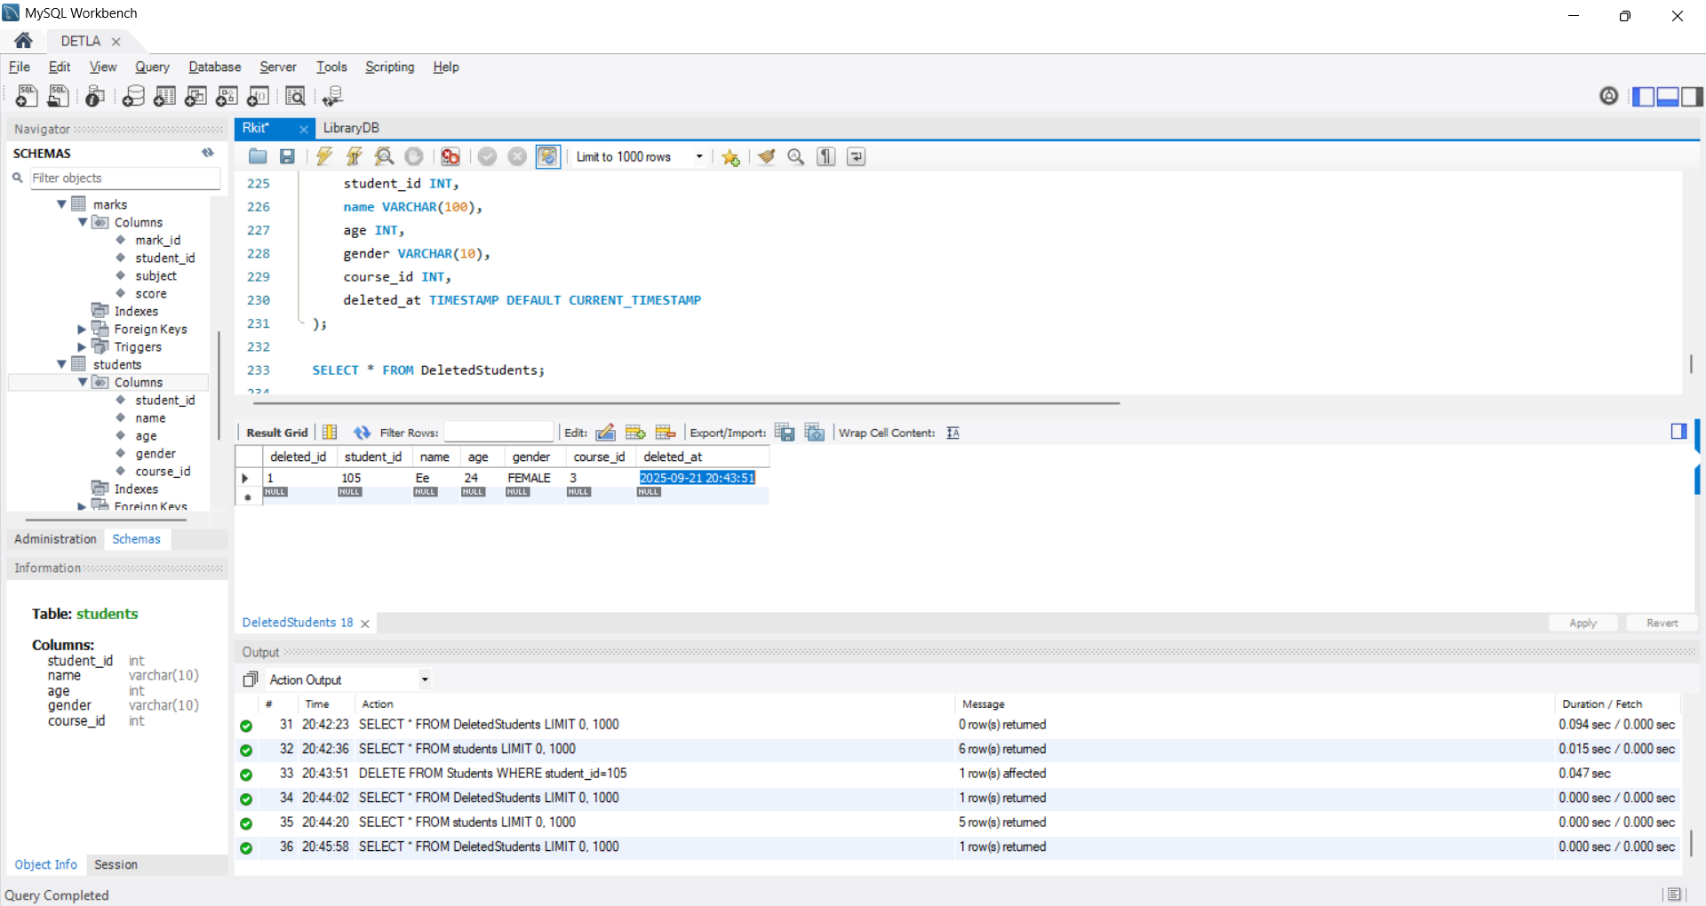

**Assignment 10: Views + Backup**

1. Create a **View** StudentCourseView that shows student name + course name.

CREATE VIEW stud AS SELECT students.name,courses.course_name FROM students inner join courses on students.course_id = courses.course_id;

select *from stud;

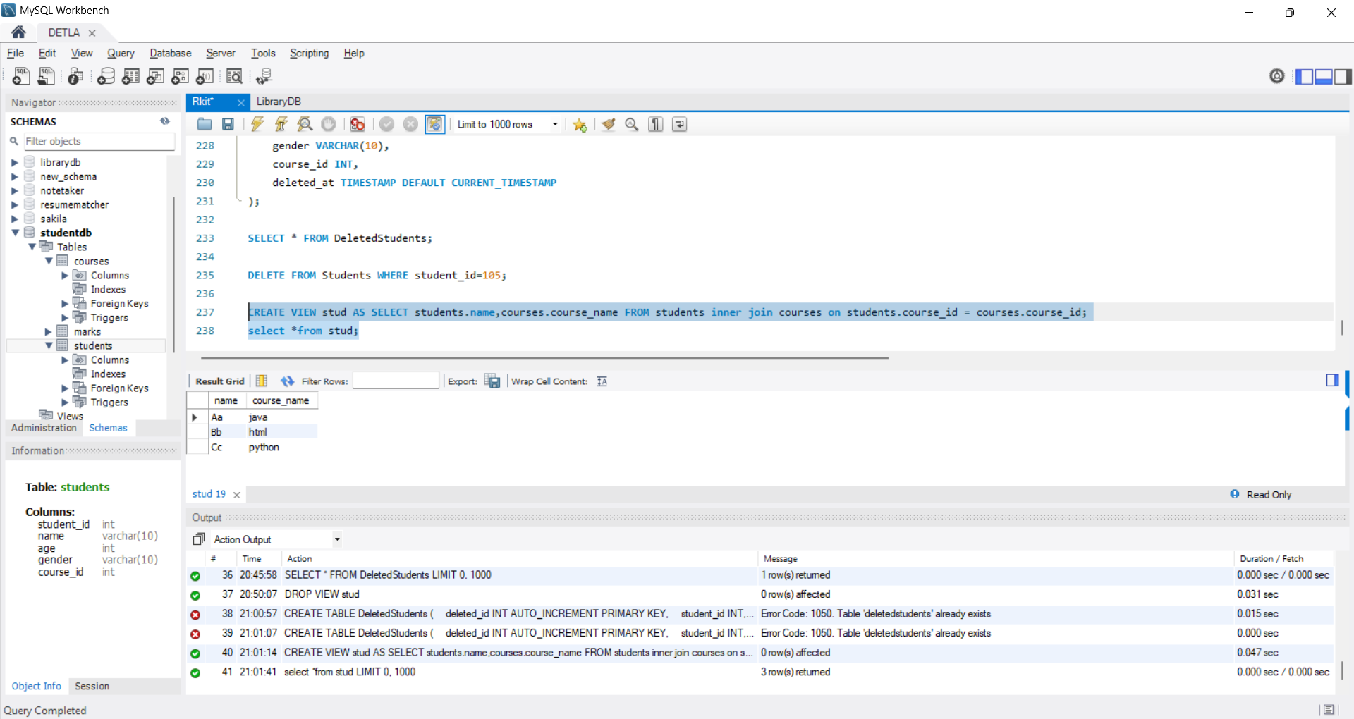

1. Query from the view to find students enrolled in “Database Systems”.

SELECT name FROM stud where course_name='Database System';

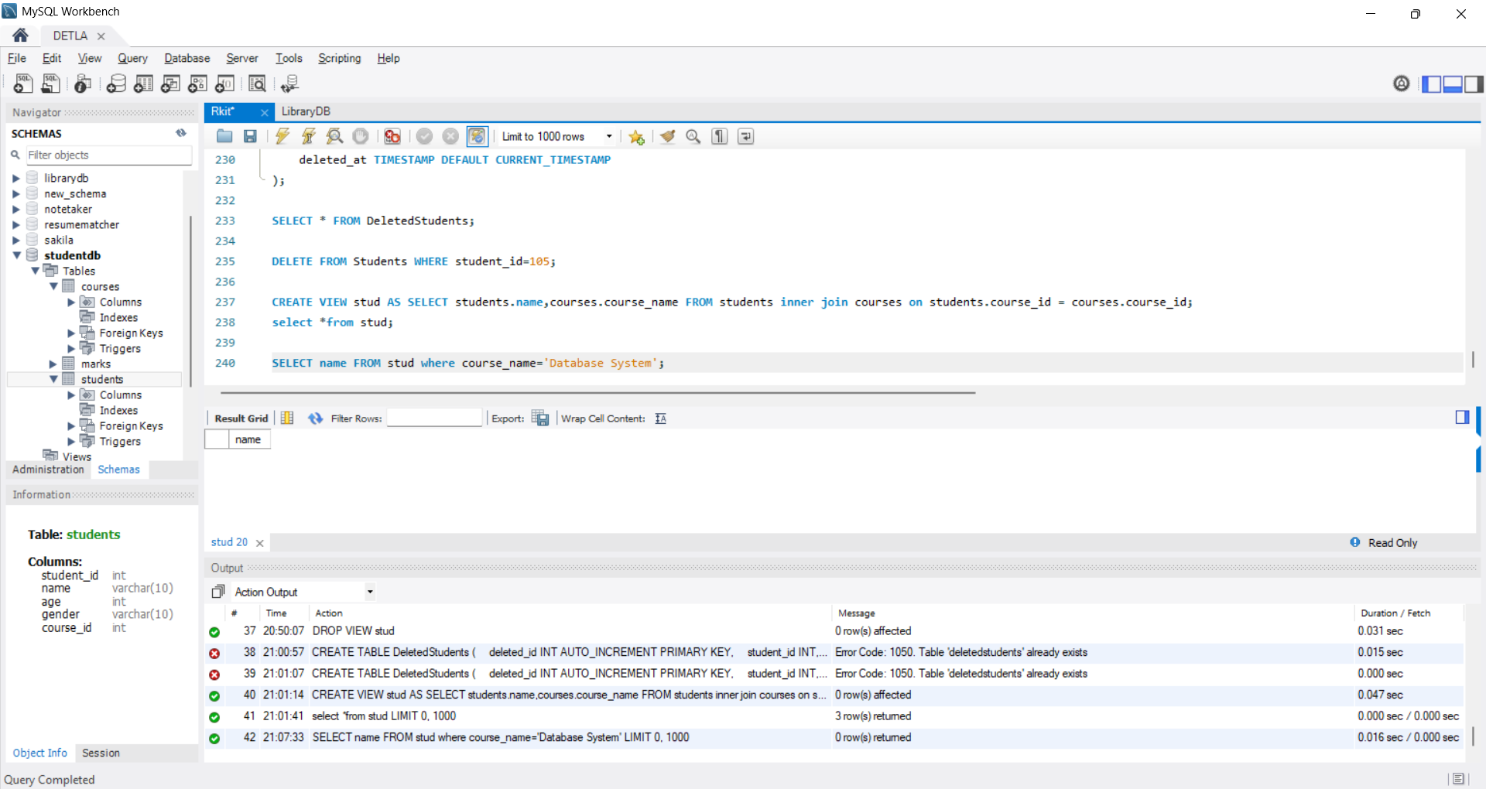

1. Export your database using Workbench (**Backup**).

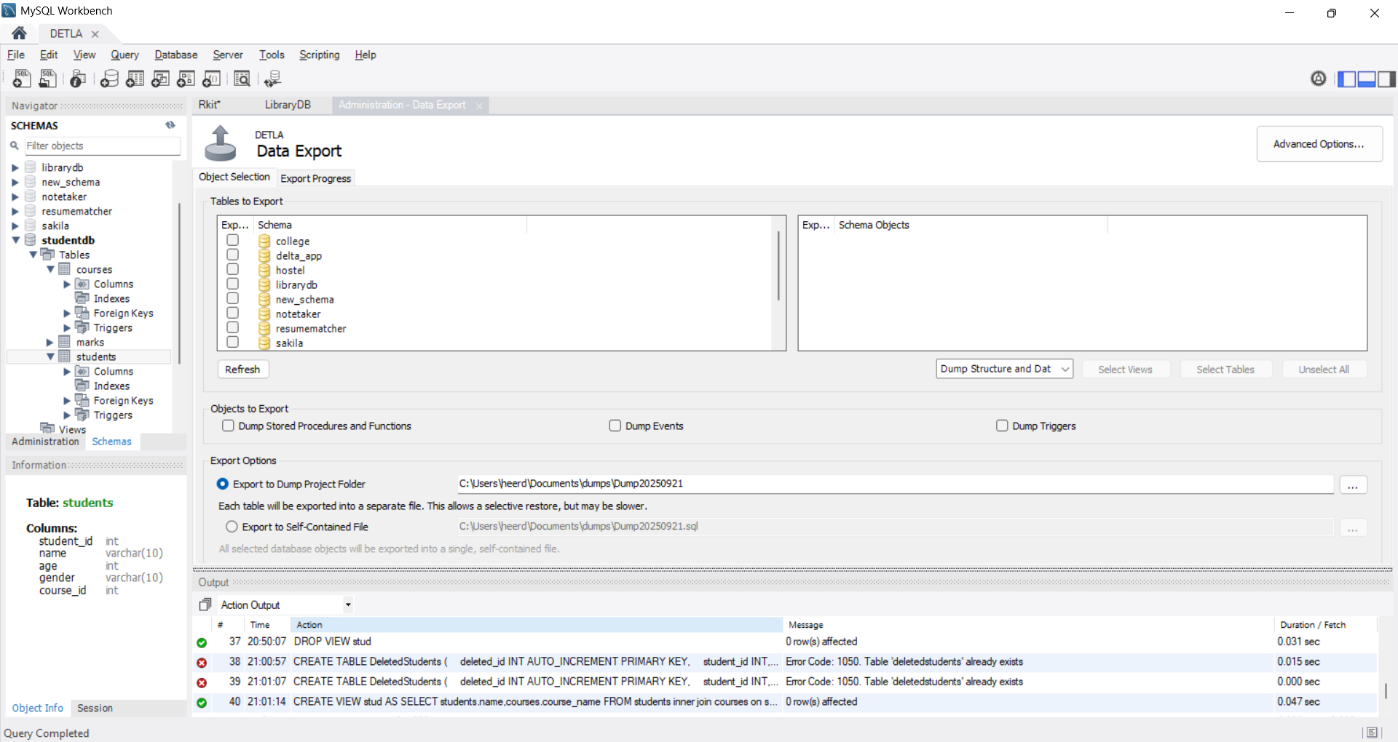

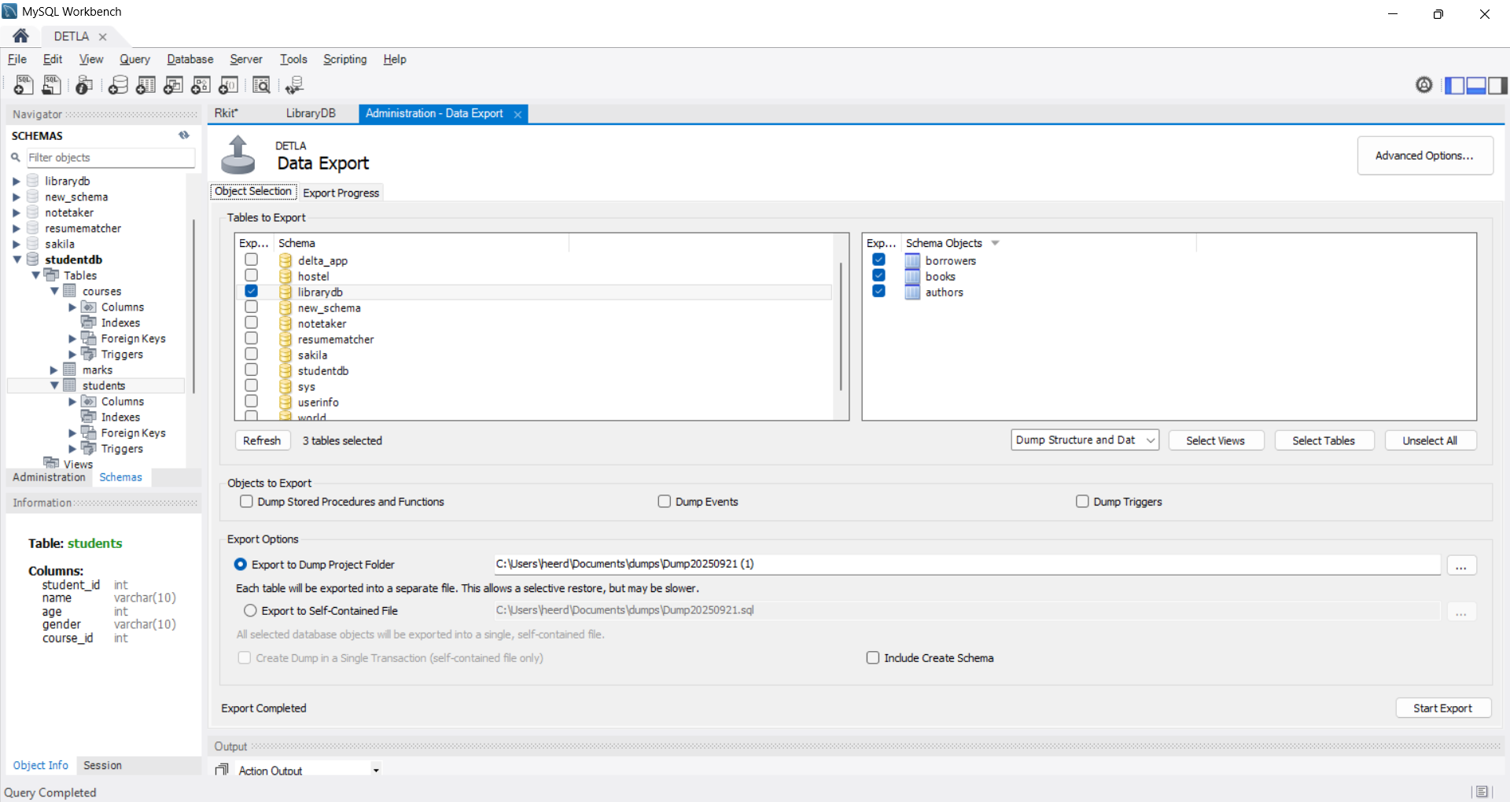

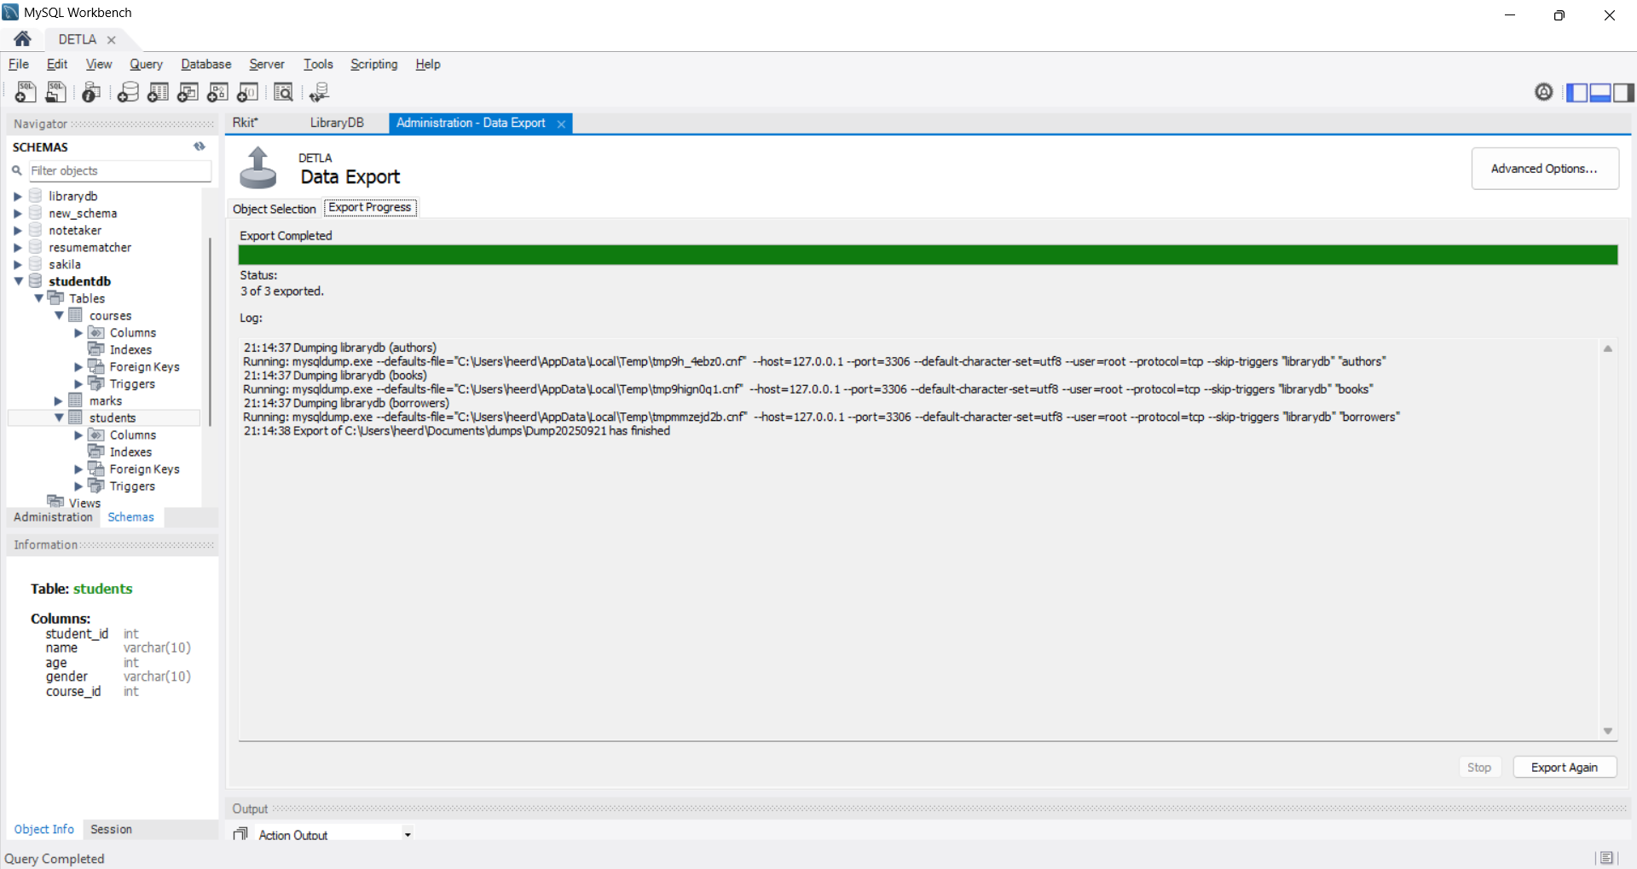

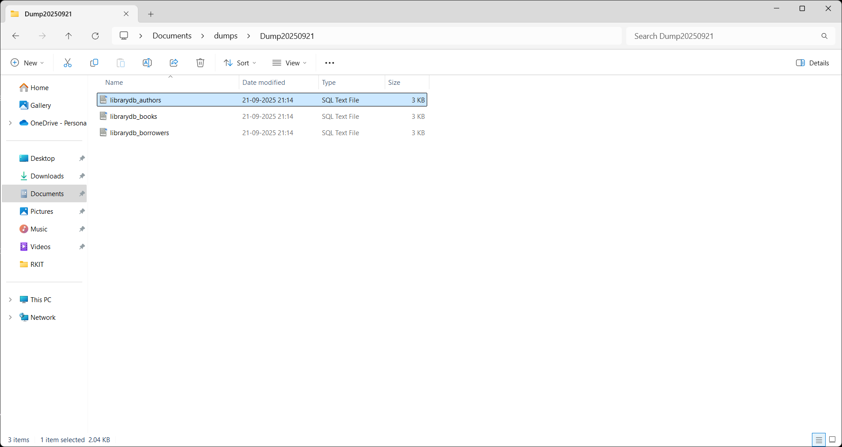

1. Restore it into a new schema StudentDB_Copy.

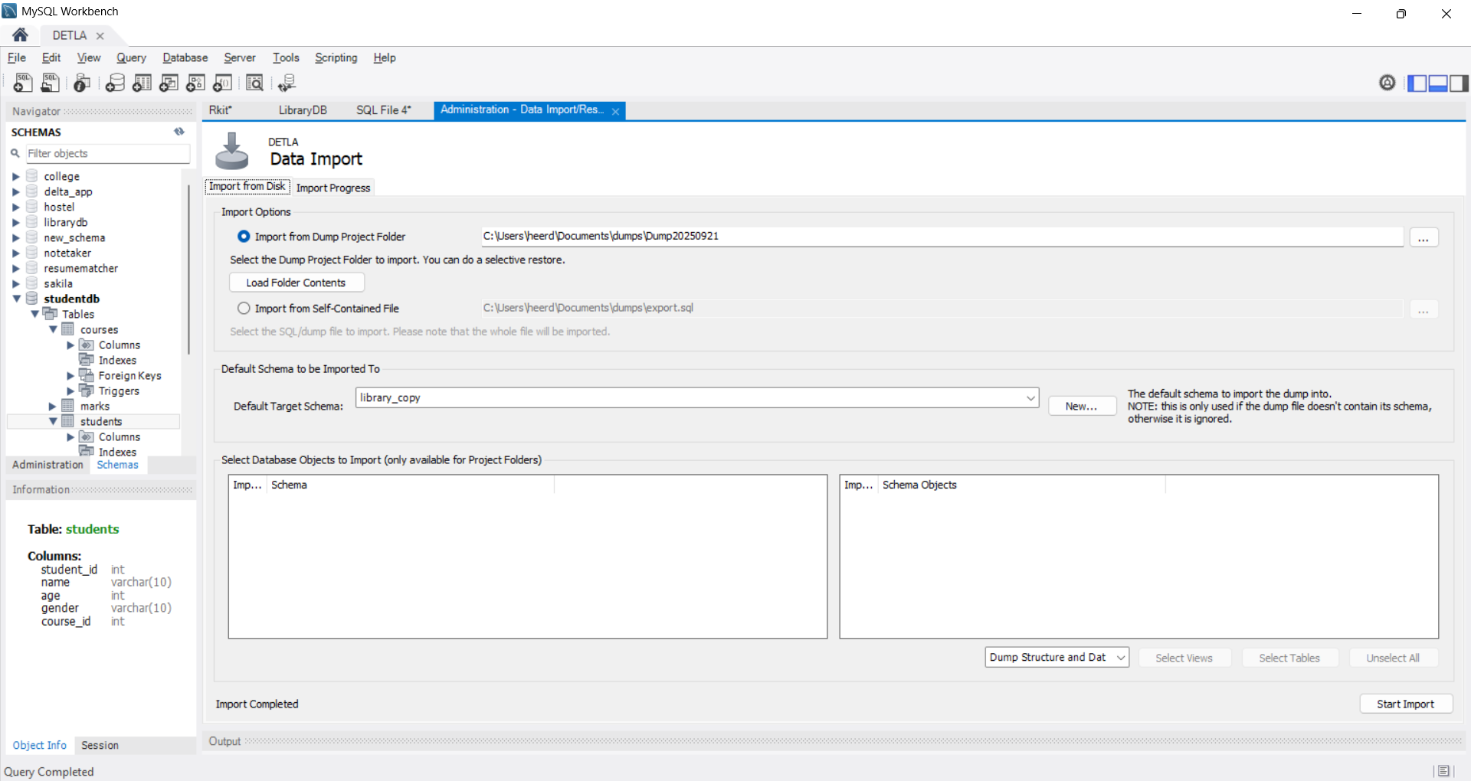

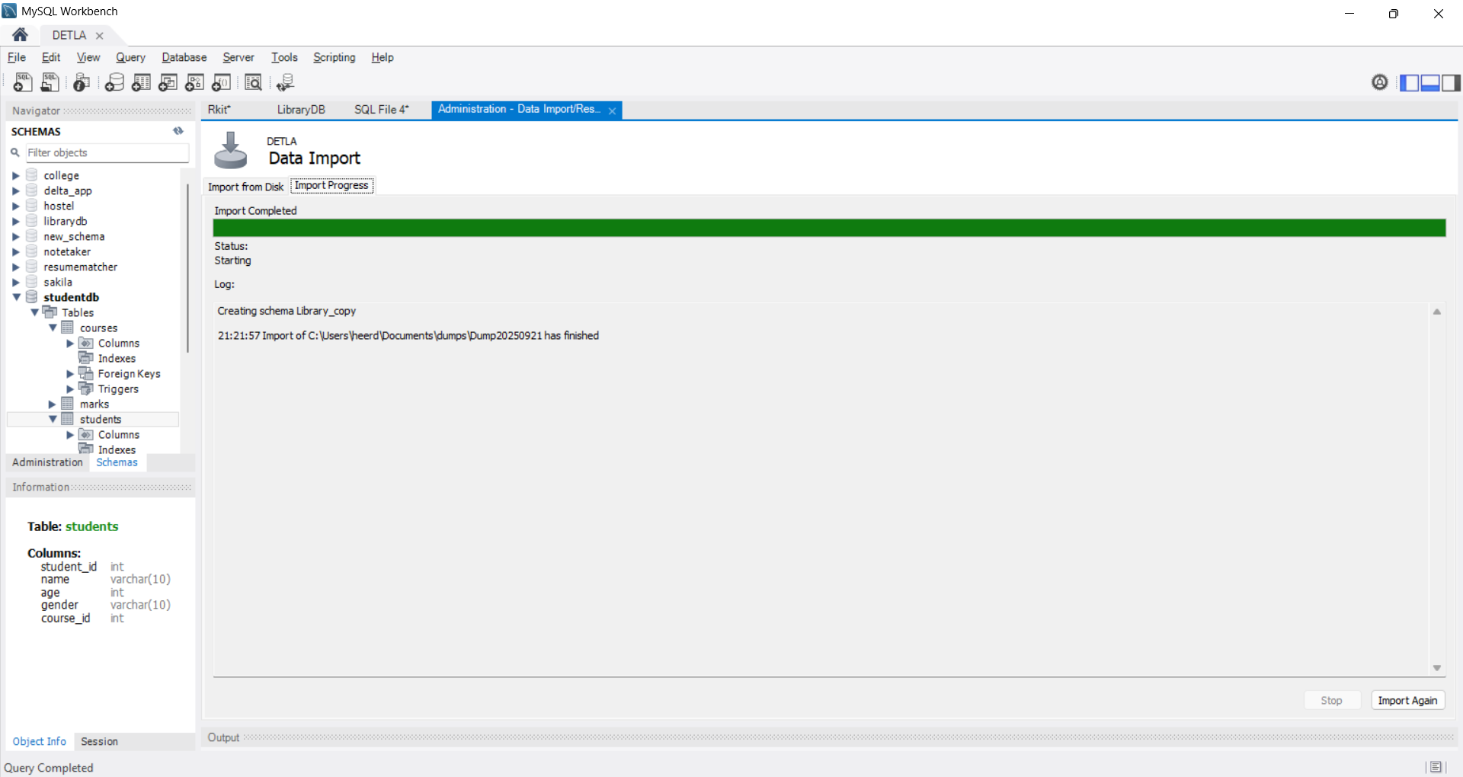

**Final Test/Project for Week 2**:  
Design a **Mini Employee Payroll System** with tables:

* Employees (emp_id, name, dept_id, salary)
* Departments (dept_id, dept_name)
* Salaries (emp_id, month, amount)

Tasks to include:

* Complex joins (employees + department + salaries).
* Subquery to find employees earning above department average.
* SP to calculate yearly salary.
* Trigger to auto-log salary insertions.
* Create a view for employee salary summary.
* Take a backup and restore it to prove DB portability.

CREATE TABLE Departments (

dept_id INT PRIMARY KEY,

dept_name VARCHAR(50) NOT NULL

);

CREATE TABLE Employees (

emp_id INT PRIMARY KEY,

name VARCHAR(50) NOT NULL,

dept_id INT,

salary DECIMAL(10,2),

FOREIGN KEY (dept_id) REFERENCES Departments(dept_id)

);

CREATE TABLE Salaries (

emp_id INT,

month VARCHAR(20),

amount DECIMAL(10,2),

PRIMARY KEY(emp_id, month),

FOREIGN KEY(emp_id) REFERENCES Employees(emp_id)

);

This lists all employees with their **department and salary per month**.

SELECT e.emp_id, e.name, d.dept_name, s.month, s.amount

FROM Employees e

INNER JOIN Departments d ON e.dept_id = d.dept_id

INNER JOIN Salaries s ON e.emp_id = s.emp_id

ORDER BY e.emp_id, s.month;

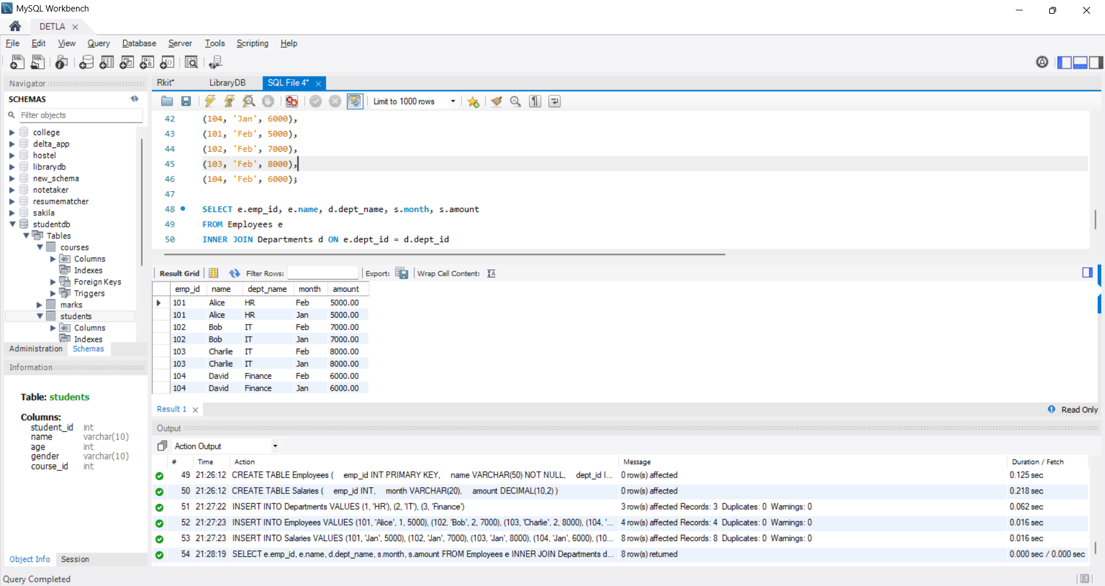

Finds employees whose salary is higher than their department’s average.

SELECT name, dept_id, salary

FROM Employees e

WHERE salary > (

SELECT AVG(salary)

FROM Employees

WHERE dept_id = e.dept_id

);

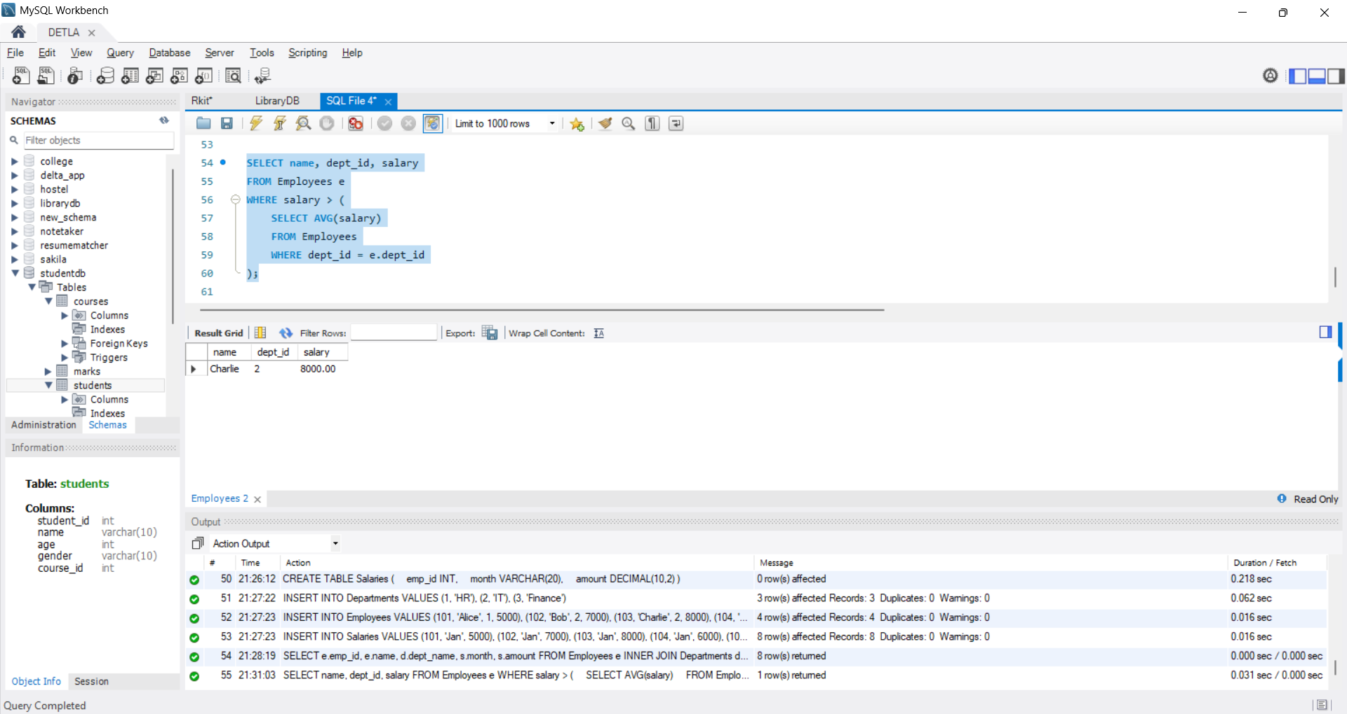

Calculate Yearly Salary

DELIMITER $$

CREATE PROCEDURE GetYearlySalary(IN emp INT)

BEGIN

SELECT e.name, SUM(s.amount) AS yearly_salary

FROM Employees e

JOIN Salaries s ON e.emp_id = s.emp_id

WHERE e.emp_id = emp

GROUP BY e.name;

END $$

DELIMITER ;

CALL GetYearlySalary(102);

**Auto-log salary insertions**

-- Create a log table

CREATE TABLE SalaryLog (

log_id INT AUTO_INCREMENT PRIMARY KEY,

emp_id INT,

month VARCHAR(20),

amount DECIMAL(10,2),

log_time TIMESTAMP DEFAULT CURRENT_TIMESTAMP

);

-- Trigger

DELIMITER $$

CREATE TRIGGER after_salary_insert

AFTER INSERT ON Salaries

FOR EACH ROW

BEGIN

INSERT INTO SalaryLog(emp_id, month, amount)

VALUES (NEW.emp_id, NEW.month, NEW.amount);

END $$

DELIMITER ;

**View: Employee Salary Summary**

CREATE VIEW EmployeeSalarySummary AS

SELECT e.emp_id, e.name, d.dept_name, SUM(s.amount) AS total_salary

FROM Employees e

JOIN Departments d ON e.dept_id = d.dept_id

JOIN Salaries s ON e.emp_id = s.emp_id

GROUP BY e.emp_id, e.name, d.dept_name;

SELECT * FROM EmployeeSalarySummary;

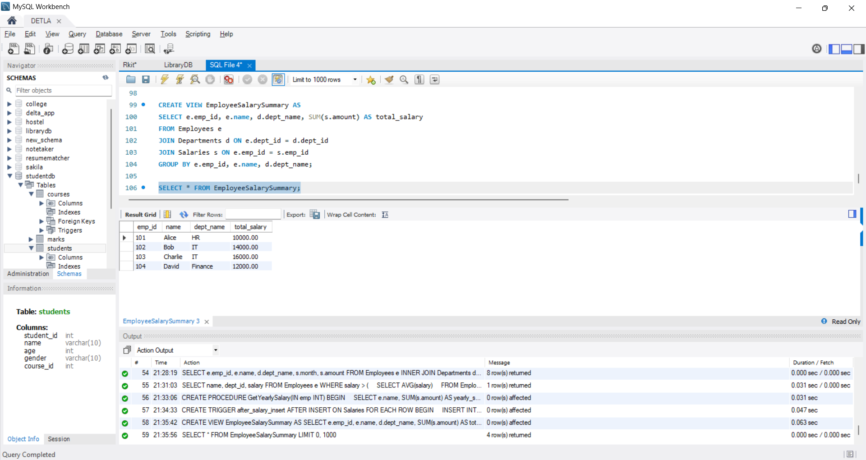

Take a backup and restore it to prove DB portability.

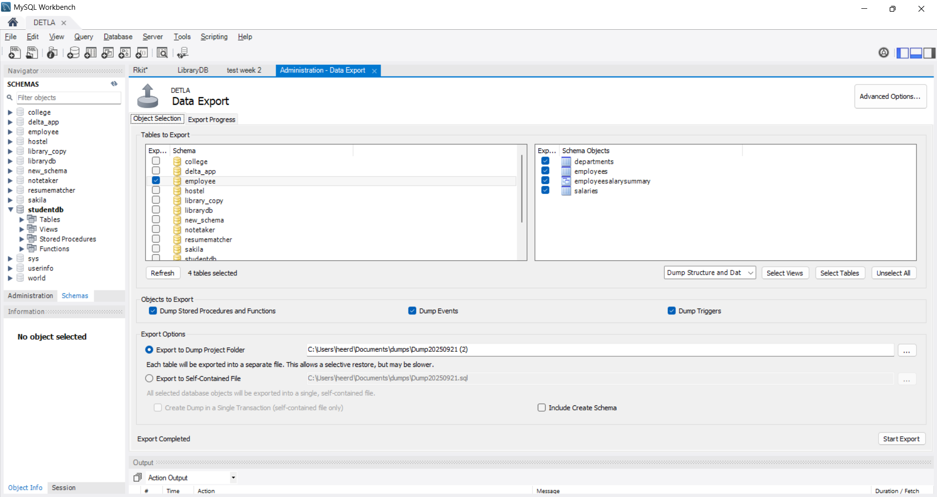

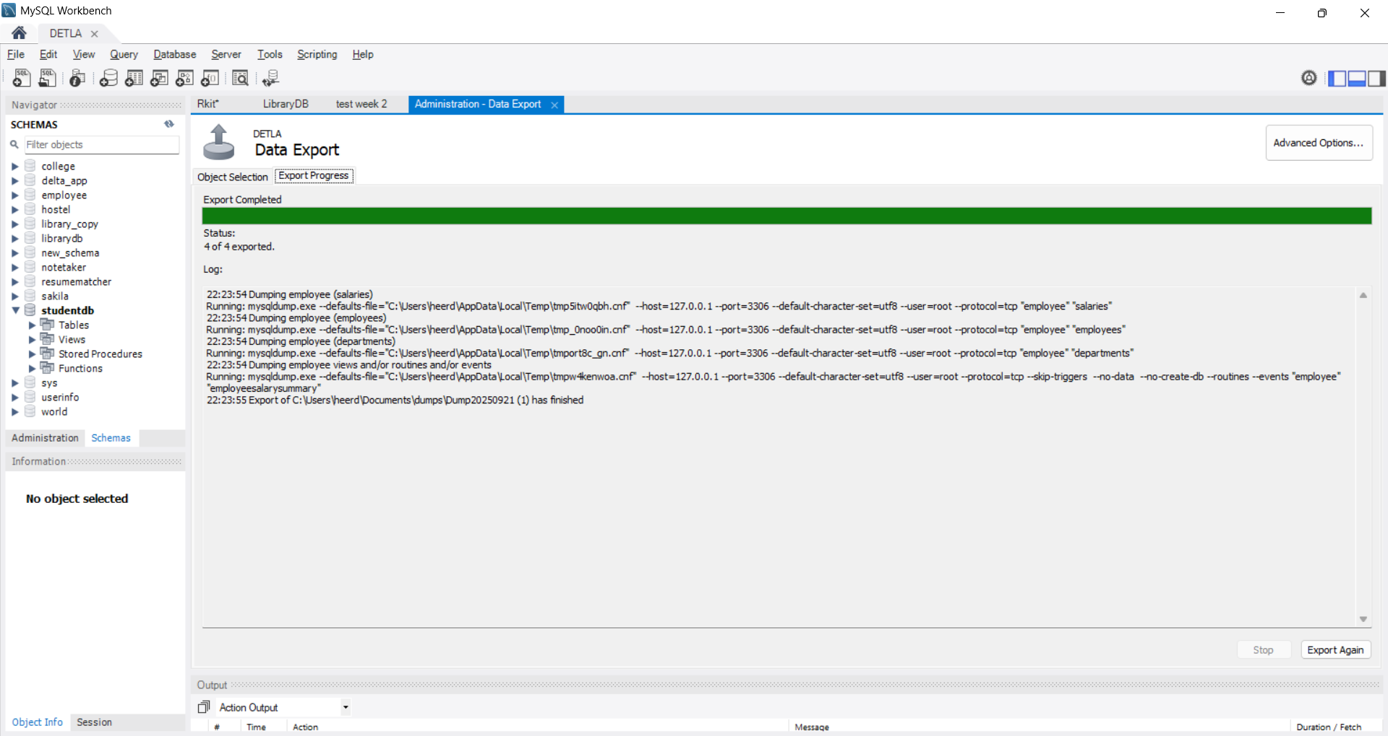

Restore:

